Name _______________________ Homeroom _____________

Topic 17 Homework Packet

Conversion Chart
1 foot = 12 inches (in) 1 yard = 3 feet (ft) = 36 in 1 mile (mi) = 1,760 yd = 5,280 ft
1 gallon = 4 quarts (qt) 1 quart = 2 pints (pt) 1 pint = 2 cups (c)
1 cup = 8 fluid ounces (fl oz) 1 ton (T) = 2,000 pounds (lb) 1 pound = 16 ounces (oz)
1 km = 1,000 m 1 m = 100 cm 1 m = 1,000 mm 1 cm = 10 mm
1 L = 1,000 mL 1,000 mg = 1 g 1,000 g = 1 kg 1 tablespoon (tbsp) = 3 teaspoons(tsp)

Section 17 – 1: Converting Customary Units of Length
Convert each unit.
1. 75 ft = _________ in. 2. 2 mi = _________ yd

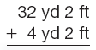
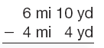
3. 4.

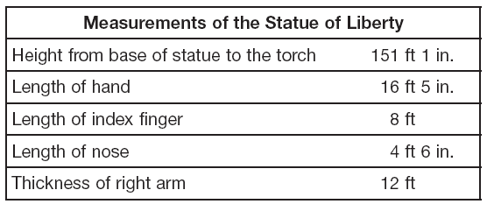
The Statue of Liberty was a gift to the
United States from the people
of France. Some of the dimensions of the
statue are shown here.

5. What is the height, from the base of
the statue to the torch, in inches?

6. What is the thickness of the statue’s right arm in yards?

7. Which is equal to 435 in.?

A 37 ft 5 in. B 36 ft 3 in. C 12 yd D 12 ft 3 in.

8. The tail of a Boeing 747 airplane is 63 feet 8 inches tall. How many inches tall is the tail?

9. A board is 2 feet long. Beverly paints 6 inches of the board. What fractional part of the board does Beverly paint?

10. Draw a picture to show how many inches are in 8 feet.

Section 17 – 2: Converting Customary Units of Capacity
Convert each unit.
1. 2 qt = _______ pt 2. 3 gal = ________ pt 3. 9 pt = ________c

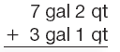
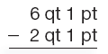
4. 5.

6. Mason made 5 quarts of salsa. Write an expression that could be used to find the number of cups Mason made.

7. If you needed only 1 c of milk, what is your best choice at the grocery store—a quart container, a pint container, or a ½ gal container?

8. Jeff needs 3 cups of carrots for a recipe. How many pints does he need?

9. The Turtle Bend habitat holds 30,000 gallons of water. How many quarts of water can the exhibit hold?

10. Which of the following is equivalent to 1 c?

A 4 fl oz B 2 pt C 48 tsp D 32 tbsp

Section 17 – 3: Converting Customary Units of Weight
Convert each unit.
1. 2.5 lb = _______ oz 2. 56 oz = ______lb ______oz 3. 4,000 lb = ______T

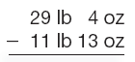
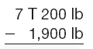
4. 5.

6. The world’s heaviest lobster weighed 44 pounds, 6 ounces. How many ounces did the lobster weigh?

7. Karla bought 2 lb of red beads, 1 ¾ lb of green beads, and 10 oz of string at the craft store. How much did Karla’s supplies weigh altogether?

8. A bale of cotton weighs about 500 pounds. How many tons will 20 bales of cotton weigh?

9. Which of the following is equivalent to 92.5 lb?

A 1,472 oz B 1,480 oz C 1,479 oz D 1,488 oz

10. Explain the difference between 1 fl oz and 1 oz.

Section 17 – 4: Converting Metric Units of Length
Convert each unit.
1. 25 m = ________ cm 2. 4,000 mm = ________ cm 3. 4.2 km = ________ m

Mount Saint Helens, a volcano in the state of Washington, erupted on May 18, 1980. Before the eruption, Mount St. Helens was 2,950 m high. After the eruption, it was 2,550 m high.

4. What is the difference in height of Mount St. Helens before and after the eruption expressed in meters?

5. Before the eruption, how many kilometers high was Mount St. Helens?

6. Which of the following is equal to 2 m?

A 200 mm B 20 cm C 200 km D 2,000 mm

7. Explain how you would convert 4 m to millimeters.

8. Each 5 centimeters that an archeologist digs is called a spit. How many millimeters are in a spit?

9. A ship is 180 meters in length. How would you find how many centimeters are equal to 180 m?
A. 180 X 10 B. 180 ÷ 10 C. 180 X 100 D. 180 ÷ 100

10. The Statesman Capitol 10,000 in Austin is the largest race of its kind in Texas. If the racers run 10,000 meters, how many kilometers do they run?

Section 17 – 5: Converting Metric Units of Capacity
Convert each unit.
1. 5 L = _________ mL 2. 1,298 mL = ________ L 3. 82 mL = ________ L

4. A drink pitcher holds 5 liters of lemonade. If each person gets 250mL per serving, how many servings will the pitcher serve?

Which capacity is most reasonable for each container? (circle one)

5. coffee mug 300 mL or 3 L

6. cleaning bucket 500 ml or 5 L

7. Leaving the water running while brushing your teeth can use 11 liters of water. How many milliliters is 11 liters?

8. Which of the following is equal to 2 mL?

A 20 L B 0.2 L C 0.02 L D 0.002 L

9. Suppose you have a 100-mL cup, a 300-mL cup, and a 500-mL cup. List two different ways you can measure exactly 1 L.

10. The CN Tower in Toronto, Canada, is 553 meters tall. How tall is the tower in centimeters?

Section 17 – 6: Converting Metric Units of Mass
Convert each unit.
1. 15,000 g = ________ kg 2. 4,298 kg = _______ g 3. 648 g = ________ mg

Compare the units. Use > , < , or =
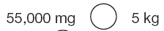
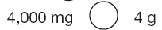
4. 5.

6. What is x? 40,000 mg = 10x g

A 400 0 B 40 C 4 D 0.4

7. A recipe that serves two people calls for 1,500 mg of baking soda. You want to make enough for 10 people. How much baking soda will you need, in milligrams?

8. A Texas longhorn bull weighs about 600 kilograms. How many grams does a bull weigh?

9. Terri is beginning a science experiment in the lab. The instructions call for 227 mg of potassium. What is the difference between this amount and 1 gram?

10. List the following masses in order from least to greatest: 6,000 mg, 2 kg, and 5 g

